- Project Selection and Needs Identification
For every problem there is a solution that is simple, neat, and wrong.—H.L. Mencken
Traditionally, companies have organized resources based on functions such as accounting, engineering, finance, manufacturing, and marketing. It is often more effective to organize around projects that are of significant value and align resources to meet the needs of the project. This means that traditional departments and middle management are being de-emphasized and the role of projects is growing. Capstone design projects provide a great opportunity to gain experience in the management and execution of a project. One of the first and most important decisions encountered is selecting a project to pursue.
The objective of this chapter is to provide pragmatic guidance in the project selection phase. A description of design and engineering projects is presented, followed by advice on how projects can be selected by engineering students who wish to put design principles into practice. The chapter addresses how to identify the needs of the end-user and provides guidance for conducting background research. All of this information is brought together in a Problem Statement that identifies the needs, the goals of the project, and research on the technology.
Learning Objectives
By the end of this chapter, the reader should:
  - Have an understanding of the types of projects that electrical and computer engineers undertake.
  - Understand and be able to apply criteria for project selection.
  - Know how to determine, document, and rank end-user needs.
  - Be aware of resources available for conducting research surveys.
  - Have selected a project concept and developed a Problem Statement.
  - Engineering Design Projects
This section provides a classification of design and describes some of the types of projects undertaken by practicing engineers and those tackled in student projects. In reality, most projects don’t fit neatly into the categories presented, but are some combination of them. The objective of a design project is to create a new artifact (system, component, or process) to meet a given need. Within the design domain there are different types of designs that are classified broadly into three categories of Creative, Routine, and Variant designs [Cro00].
Creative designs represent new and innovative products. An example of a creative design is the Palm Pilot™ Personal Digital Assistant (PDA). While the idea for the PDA had been around for awhile, earlier attempts at developing the technology, notably the Apple Newton, were unsuccessful. This was primarily due to unreliable handwriting recognition that frustrated the user. However, Palm Computing had the creative idea to develop a simplified handwriting language, Graffiti, which eliminated the need for natural handwriting recognition. The Palm Pilot is a great example of a creative design—it is simple (four basic functions), fits in your pocket, and is easy to use. This innovation spawned a huge hand-held computing industry.
Variant designs are variations of existing designs, where the intent is to improve performance or add features to an existing system. Many engineering projects fall into this category. For example, the objective may be to increase accuracy or system throughput.
Routine designs represent the design of devices for which theory and practice are well-developed. Examples are DC power supplies, analog and digital filters, and basic digital components such as adders and comparators. Routine designs are often components of more complex creative and variant designs.
Within these three categories of design, there are many different types of projects. Systems engineering and systems integration projects represent the synthesis of many subsystems into a larger system. They may be creative or variant designs, but have unique challenges since they are typically large and involve many people and technologies. Adherence to good design processes is important for their success. Engineers are often engaged in systems test, where the objective is to ensure that a system meets stated requirements and the needs of the user. Examples include the testing of systems for use in space and military environments.
The objective in experimental design projects is to design experimental procedures and apparatus for determining the characteristics of a system. For example, an engineering team may test a system under a variety of operating conditions. Example 2.3 presented later in the chapter is such a project, where the objective was to design a series of experiments to test the feasibility of gigabit Ethernet technology in a military environment. The test explored the impact of environmental factors such as temperature and vibration, and further used this data to estimate the operating lifetime of the Ethernet board. Upon completion of this project, the team made recommendations as to the allowable operating ranges of the technology.
The objective in analysis projects is to analyze some aspect of an existing system to improve or correct it. For example, a system or process may be failing in the field and the source of the failure unknown. Tools such as the Failure Mode Effects and Analysis technique may be applied in this situation to identify the sources of failure. In technology evaluation projects, technologies are assessed to determine if they can be used in a given application. This may be to determine if the technology can improve an existing system, or to characterize its operating performance.
The objective of a research project is to perform research or experiments with the goal of discovering or creating a new technology. The fundamental difference between this and other types of projects is that the ultimate outcomes are unknown. Most engineering research falls under the category of applied research. This refers to the creation of new technology or systems based on existing technology and theory developed from fundamental research. Fundamental research emphasizes the discovery of new scientific principles without necessarily having an intended application. Fundamental research is very valuable, but not typically a part of design projects.
  - Sources of Project Ideas
Depending upon your situation, you may have the opportunity to identify and select your project. The list below provides some places to search for project ideas:
- Industry sponsored projects. Many companies will sponsor projects and are happy to do so, particularly if you have worked for them on an internship.
- Engineers without Borders (www.ewb-usa.org). This organization sponsors student projects to improve the quality of life in developing countries.
- www.FreeRandD.com. This is a clearinghouse for businesses and students teams to collaborate on projects. It allows businesses to post capstone project ideas for students to work on, while students can post resumes and project interests.
- Your campus and local community. In our school, a number of student teams have identified novel projects by asking other departments on campus for ideas. They have also been successful in approaching local community organizations for ideas, such as museums and research institutes.
- Brainstorm. Get together with a group of your peers and brainstorm on project ideas. You will be surprised at how many project ideas you can develop in a good brainstorming session (see Chapter 4). Do not only consider project ideas, but also brainstorm to identify problems that need solutions.
  - Project Feasibility and Selection Criteria
This section provides questions to consider when examining the feasibility of a project. George H. Heilmeier (an electrical engineer who has held positions as Chief Technology Officer of Texas Instruments, Director of the Defense Advanced Research Projects Agency, and CEO of Bellcore) developed a set of questions to answer when starting a new project [Sha94]. Heilmeier argued that all projects must be tied to the goals of the organization, and applied this by asking the following questions:
- What are you trying to do? Articulate your goals using absolutely no jargon.
- How is it done today, and what are the limitations of current practice?
- What is new in your approach, and why do you think it will be successful?
- Who cares? If you are successful, what difference will it make?
- What are the risks and payoffs?
- How much will it cost? How long will it take?
- What are the midterm and final exams to check for success?
Heilmeier credits successful completion of projects that he managed to answering these questions up-front and adhering to disciplined project management processes.
A second perspective is offered from an organizational project management viewpoint [Gra02] that provides the following criteria for project selection:
  - The project must be tied to the mission and vision of the organization. Believe it or not, organizations often spend resources fruitlessly on projects that don’t meet this criterion. To be fair, there is always risk associated with a project and it is sometimes hard to judge exactly how well a project meets this criterion. For engineers who are new to an organization, it is hard to judge a project’s importance relative to the mission and goals, but if you find yourself in this situation, do not be afraid to ask some questions. Novices ask basic questions that are often overlooked by those who are highly experienced or intimately involved in a project.
  - Must have payback. An economic analysis should be done to estimate if the project will make a profit. Much of this is outside the scope of this text, requiring marketing and financial analyses. Chapter 10 covers the basics of project cost estimation that will help in trying to answer this question.
  - Should have selection criteria. Sound criteria for selecting among competing projects should be employed. The example at the end of this section demonstrates the application of criteria in project selection.
- Objectives of the Project should be SMART: Specific, Measurable, Assignable, Realistic, Time-Related. Chapter 3 addresses how to determine project requirements that are Specific and Measurable. Assignable, Realistic, and Time-Related all refer to project management aspects that are covered in Chapter 10. The objective is to develop tasks that are assigned to groups or individuals and realistically can be completed in the given timeframe.
The following example demonstrates how to apply a project selection model using a method known as the Analytical Hierarchy Process. AHP is a decision making method that is described in Appendix B and is utilized frequently throughout the text – the reader should read Appendix B prior to proceeding with this example.

Example 2.1 A project selection model for capstone design.
Assume that you are part of a capstone design team that has the opportunity to select their project from competing project ideas. The steps in making a decision using AHP are to select the criteria that drive the decision, determine relative weights of the criteria, rate the alternatives (in this case project concepts) against the criteria, to compute a weighted score for each of the alternatives, and then review the decision.

Step 1: Determine the selection criteria
To select the criteria, assume that the team brainstorms to determine the following criteria that interest the team members:
A – Match to team skills
B – Technical complexity
C – Creativity
D – Market potential
E – Industry sponsorship

Step 2: Determine the criteria weightings
Assume the team applies the method of pairwise comparison to determine the weights as shown in Appendix B. In order to do so, the team systematically compares each criterion to all others using the following scale of relative importance:
1 = equal, 3 = moderate, 5 = strong, 7 = very strong, 9 = extreme.
Again, details of pairwise comparison are outlined in Appendix B and the results are below.

Criteria | A | B | C | D | E | Weight
A | 1 | 5 | 5 | 3 | 3 | 0.52
B | 1/5 | 1 | 3 | 1/3 | 1/3 | 0.12
C | 1/5 | 1/3 | 1 | 1 | 3 | 0.09
D | 1/3 | 3 | 1 | 1 | 5 | 0.18
E | 1/3 | 3 | 1/3 | 1/5 | 1 | 0.09

This is an important step and one often overlooked – the team has identified what is important to it in project selection. It is clear that match to the team skills (criterion A) is most important, by a large margin, followed by market potential.
Step 3: Identify and rate alternatives relative to the criteria
Assume that the team identifies three potential projects ideas: 1 – IEEE sponsored robot competition, 2 – Industry sponsored project to design a new test protocol, and 3 – Design of an item-finder device to help people locate lost items. Furthermore, the team goes through the process of rating each project relative to the criteria as outlined in Appendix B. These ratings are reflected in the decision matrix in the next step.
Step 4: Compute scores for the alternatives
The decision matrix below is constructed and the scores for the alternatives determined.

Selection Criteria | Weights | Alternatives
Selection Criteria | Weights | Project 1 | Project 2 | Project 3
A (Match to skills) | 0.52 | 0.40 | 0.20 | 0.40
B (Technical Complexity) | 0.12 | 0.40 | 0.30 | 0.30
C (Creativity) | 0.09 | 0.45 | 0.20 | 0.35
D (Market potential) | 0.18 | 0.05 | 0.35 | 0.60
E (Industry sponsorship) | 0.09 | 0.00 | 1.0 | 0.00
Score |  | 0.31 | 0.31 | 0.38

Step 5: Review the decision
Project 3 (item finder) is rated the highest among the three choices based upon the weights determined by the team members. It is a good match to the team skills, but also matches their desire to solve a problem with good market potential. The remaining two projects are rated about equal.
  - Needs Identification
Often a customer, client, or supervisor comes to you with a problem to solve and you must determine the needs or requirements for the solution to the problem. In other words, determine the voice of the customer. This seems like a simple statement—ask the customer what they want and you are done, right?
As an illustration, let’s say a client comes to you with the following request—The traffic at the front of campus is too congested. I would like you to design a new traffic lane for northbound traffic exiting at the intersection at the front of the college. So you design this new lane and have it added to the intersection. However, you find out three months later that the traffic congestion has decreased a little bit, but it is still a significant problem. So what went wrong? Clearly you did what was asked of you, but the problem was not solved, meaning that you were solving the wrong problem. The real problem was to improve the flow of traffic at the entrance. In this case, the client gave both the problem and the solution all in one statement. That is fine if a careful feasibility study was done and it was known that the additional traffic lane would alleviate the problem, but that was not the case here. This hypothetical situation is not so far fetched and happens in practice via neglect to do the up-front research or because underlying assumptions change. The point is that the correct problem should be identified and solved.
It would be better if the client had simply asked to improve the traffic flow, providing the opportunity to analyze the situation and develop different design options. Some questions to be asked in this situation are: How much additional traffic is there? At what times does this happen? Where is the traffic coming from? What is an acceptable waiting time at the intersection? It may be that several new lanes are needed, or perhaps the sequencing of the traffic signals is wrong, or maybe a new entrance could be added for less cost and improved traffic flow.
The lesson is that customers often come with the problems and solution all wrapped up together. When this is done, the design space, the space of all possible solutions to the problem, is unnecessarily limited. Be ready to tactfully challenge the assumptions and ask questions to get to the root of the problem. Ask clarifying questions, analyze, pick apart the request, and focus on the problem, not the solution.
Researchers and practitioners have examined the problem of eliciting needs, and it is an important pre-requisite for developing good engineering requirements specifications. Ulrich and Eppinger [Ulr03] proposed a process for obtaining the voice of the customer using the following five steps: 1) Gather raw data from users; 2) Interpret raw data in terms of needs; 3) Organize needs into a hierarchy; 4) Determine the relative importance of the needs; and 5) Review the outcomes and the process. Each of these steps is described in the following sections.

Step 1: Gather Raw Data from Users
DILBERT® by Scott Adams
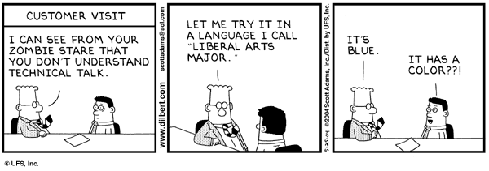

Figure 2.1 The difficulties of communicating with the customer. (Dilbert © United Feature Syndicate. Reprinted by permission.)
This is often accomplished via interviews with supervisors, key users, or people from the client organization. In cases where new products are being developed, focus groups are often employed. The advantage of interviews and focus groups is that they provide the opportunity for dialogue with the user where new ideas, concepts, and needs may emerge. Another option is direct observation, where the team goes out and examines the system in use and develops concepts for improving it. IDEO Corporation is an innovative and successful company that designs new products and systems. They rely heavily on direct observation as a technique for successfully developing innovative products [Kel01]. For example, IDEO was asked by a client to develop a new medical instrument for balloon angioplasty used in hospital operating rooms. A critical requirement from the user was that only one hand could be used to operate the device because the technician’s other hand had to be free during the procedure. From direct observation, the IDEO design team found that even though the current system was designed for one-hand use, it was impractical, and the technicians actually used both hands. IDEO designed and developed a two-handed pump that not only worked better than the one handed pump, but was quieter, easier to read, and had increased precision. This is another example of the customer specifying the solution as part of the problem statement.
Ulrich and Eppinger provide the following questions to ask during an interview:
  - When and why do you use this type of product (system)?
  - Walk us through a typical session using the product.
  - What do you like about the existing products?
  - What do you dislike about the existing products?
  - What issues do you consider when purchasing the product?
  - What improvements would you make to the product?

Step 2: Interpret the Raw Data in Terms of Needs
In this step the raw data is translated into customer needs. The needs are expressed in terms of what the system must do (a requirement) as opposed to how it is done. Statements of the customer’s needs are known as marketing requirements or marketing specifications. For example, “The system should have high-quality audio” is a need or marketing requirement from the customer regarding performance, but says nothing about how it will be achieved. Marketing requirements are short sentences that describe the need in the language of the customer. They typically do not have a numerical target and are described as a state of being for the system. Other examples of marketing requirements are, “The system should be easy-to-use,” and “The system should be able survive a drop from the runner’s height.”

Step 3: Organize Needs into a Hierarchy
The marketing requirements are organized into a hierarchy of needs arranged from the most general to the most specific in successive levels of detail as required by the problem. It is organized by functional similarity, not as hierarchy of importance (that is the next step). This hierarchy is referred to as an objective tree. An example objective tree for a portable audio device intended for use by runners is shown in Figure 2.2. The three high-level objectives determined were high-quality audio, portable, and easy-to-use. Each of these is further sub-divided into the characteristics that support the higher level. For example, portability is divided into the needs of lightweight, small, ergonomic, and the ability to operate in the environment. The environmental need is further expanded into needs that support it.

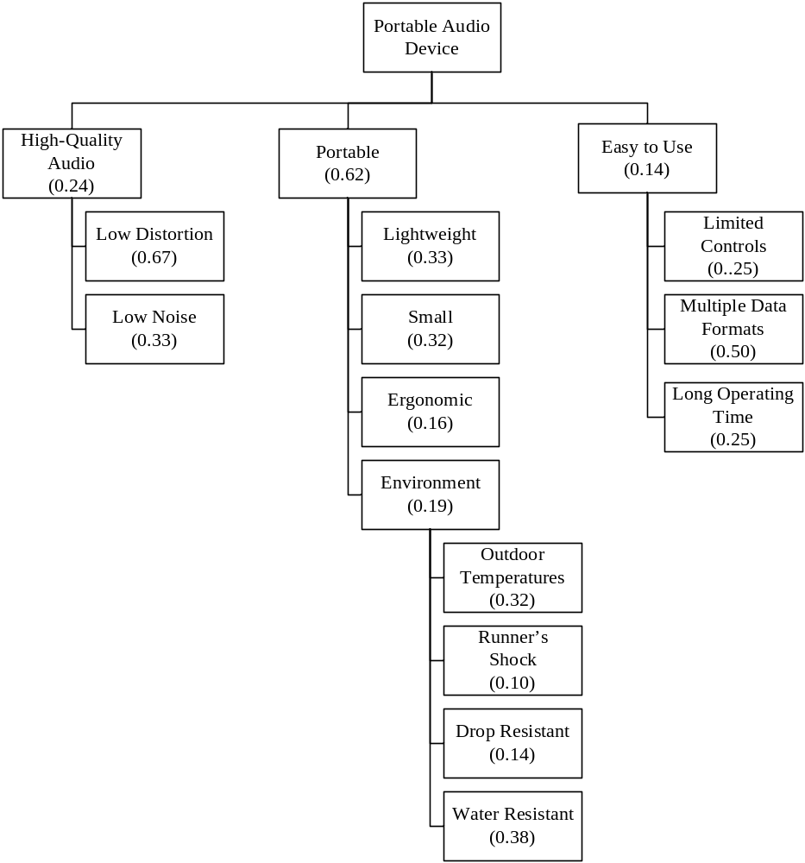
Figure 2.2 Objective tree for a portable audio device to be used by runners. The weights reflect the relative importance of needs at each level in the hierarchy as determined in Step 4 of the process.

Step 4: Determine the Relative Importance of the Needs
The relative importance of the needs is determined based upon the user needs. As we saw in Example 2.1 and as presented in Appendix B, the pairwise comparison is a good technique for determining relative importance and weighting of needs. In pairwise comparison, all needs are systematically compared to all other needs at the same level in the hierarchy. An example pairwise comparison table for this problem is shown in Table 2.1 with the resulting weights for each need indicated. This shows that portability is the most important need, followed by audio quality and ease-of-use. The weights are also reflected in the objective tree in Figure 2.2. In addition, the needs at each sublevel in the hierarchy are compared, the results of which are reflected in Figure 2.2. The rankings are used in later chapters to compare design alternatives.
Table 2.1 Pairwise comparison matrix for ranking the highest-level needs of the portable audio device. This comparison should be carried out for all levels of the objective tree.
 | High-Quality Audio | Portable | Easy-to-Use | Weight
High-Quality Audio | 1 | 1/3 | 2 | 0.24
Portable | 3 | 1 | 4 | 0.62
Easy-to-Use | 1/2 | 1/4 | 1 | 0.14

Step 5: Review the Outcomes and the Process
The design process and all of its sub-processes are methods for making good decisions, and this technique for needs identification is no different. There is a certain amount of subjectivity and judgment that goes into it; the end result should be reviewed to determine if it makes sense. The objective is to challenge assumptions, fully identify the problem, and make informed decisions.
The three outcomes of this process are the marketing requirements that identify the needs, an objective tree that provides a hierarchical representation of the needs, and a ranking of the relative importance of needs. This process may seem as though it does not apply to student design projects, but in reality it does. The questions in this chapter are certainly candidates to ask when working on company-sponsored projects. If it is not a company sponsored project, the user needs should still be considered. For example, questions can be asked of friends and co-workers who are potential users of the system, focus groups can be formed, surveys administered, and Internet bulletin boards and discussion groups employed to gather this information.
  - The Research Survey
It is important to conduct a thorough research survey while defining the project concept. Failure to do so may translate into time and money spent reinventing the wheel, while not taking full advantage of existing components, knowledge, practices, and technology. During the research phase, competing systems and technologies are identified, and based upon them the project concept refined, or in some cases abandoned. The character and strategy of the research survey is driven by the nature of the project. In general, the objective is to develop an understanding of the underlying scientific principles and demonstrate a familiarity with the state-of-the-art in the particular field. Some questions to be answered in the research survey are:
- What is the basic theory behind the concept?
- How is it currently being done?
- What are the limitations of current designs or technology?
- What are the similarities and differences between your concept and existing technologies?
- Are there existing or patented technologies that may be relevant to the design? If so, what are they and why are they relevant?
Internet Searching
The Internet is a powerful, fast, and readily accessible source for conducting research. There are many excellent search engines for locating web resources, but understand that it is important to go beyond the well-known search engines and beyond the Internet in the survey.
One of the risks, and also one of the wonderful things, about the Internet is that virtually anybody can post information. It is important to analyze websites to ensure that they are reliable and credible. There are resources available that provide pointers on how to evaluate this credibility [Mci02, Sch98], and a little common sense goes a long way. One of the important things to look for is authorship—the author should be clearly identified and any affiliations listed. Carefully determine whether the information is subjective opinion or possibly a commercial for a product. Credible sites should provide references to original sources of material. Another step is to verify website content in print media or other reliable sources.
There are thousands of search engines available, making the task of selecting one challenging. Also, there are different types of search engines: text (search for the text or keywords; subject heading or full-page text search), indexed (information categorized into directories), meta-search (engines that search other engines), and natural language processing (allowing natural language queries). A listing of search engines to try are www.altavista.com, www.AskJeeves.com, www.google.com, www.kartoo.com, and www.yahoo.com. The Librarian’s Index to the Internet, www.lii.org is a collection selected and evaluated by librarians, and according to their website, it is a “well-organized point of access for reliable, trustworthy, librarian-selected Internet resources.” This information may change rapidly and represents current information at the time of publication.
Electrical and Computer Engineering Resources
Realize that the major search engines will not find all information available on the Internet. There are many websites with specialized search capabilities related to electrical and computer engineering design.
  - EE Product Center, www.EEProductCenter.com. A website for locating electronic components and their manufacturers. It provides links to product datasheets and application notes. It has a keyword search engine and a tree structure search for finding components. For example, you can start with Op Amps and delve into sub-categories such as Precision and High-Speed.
  - Circuit Cellar, www.CircuitCellar.com. This companion website for the magazine is a great reference for designers. It emphasizes embedded systems and electronics projects with many tutorial articles and project ideas.
  - Datasheet Catalog, www.DatasheetCatalog.com. A datasheet source for electronic components and semiconductors.
  - Dr. Dobbs, www.ddj.com. The magazine and companion website are a resource for software developers that includes tips and tutorials.
  - EE Times, www.EETimes.com. Industry newspaper for electrical engineering field with information on current technology developments.
  - Electronic Design Magazine, www.EDNmag.com. This is free magazine for electrical design engineers that provides information on the latest products. The website has a number of categorized technical resources and a design ideas section.
  - ON Semiconductor, www.OnSemi.com. ON Semiconductor is a supplier of semiconductors for a wide range of applications, with a particular emphasis on power management. The website has a searchable database of over 15,000 components, and provides guidelines for component selection based on different applications.
  - The Thomas Register, www.ThomasRegister.com. This is a source for finding companies and products in North America. It allows searches for parts and equipment that may be used in a design project. It provides profiles of companies that meet the search criteria and describes the products they make.
In addition, most manufacturers of electronic components have websites providing product datasheets and application notes for their products. Application notes demonstrate how to use components in real applications. Examples are Dallas Semiconductor, Fairchild Semiconductor, Motorola, and Texas Instruments.
Government Resources
  - US Bureau of Labor Statistics, http://stats.bls.gov. This has valuable information on consumer spending information, allowing one to determine things such as how much people spend and what they spend it on. It also profiles specific industries and forecasts employment in different industry sectors.
  - US Government Official WebPortal, www.FirstGov.gov. This is an entrance to all US government web resources.
  - US Patent Office, www.uspto.gov. A searchable database of all patents back to 1790. Full text searches are available back to 1976 and full images back to 1790. It has information on the basics of patents, trademarks, and copyrights.
Journal and Conference Papers
The search should include journal and conference papers if technically detailed information on the latest theory or applications is needed.
  - ACM (Association for Computing Machinery) Digital Library, www.acm.org. Provides abstracts (full text for subscribers) for ACM journals and conference proceedings.
  - Compendex, www.engineeringvillage2.org. This provides indices to journal and conference papers in a broad scope of engineering fields, referencing material back to 1970.
  - IEEE (Institute of Electrical and Electronics Engineers) Xplore Electronic Library, www.ieee.org. Provides abstracts (full text for subscribers) to all IEEE journals, transactions, magazines, and conference subscriptions published since 1988. Abstracts for all IEEE standards are publicly available.
  - Needs and Objectives Statements
Two parts of the Problem Statement are the needs and objectives statements. The needs statement identifies and motivates the need for the project and should:
- Briefly and clearly state the need being addressed.
- Not provide a solution to the problem.
- Provide supporting information collected as outlined in Section 2.4.
- Provide any supporting statistics and anecdotes that support the need.
- Describe current limitations.
- Describe supporting processes that are needed to understand the need. This is particularly important in industry-sponsored projects having specific needs that may not be clear to the average person.
The objectives statement typically ranges from one or two sentences to one or two paragraphs in and should:
- Summarize what is being proposed to meet the need.
- Provide some preliminary design objectives (detailed requirements are developed later).
- Provide a preliminary description of the technical solution, avoiding a detailed description of the implementation. Often the input and output behavior of the system are described. The complete solution is not usually posed until after the engineering requirements are fully determined.
Example needs and objectives statements are provided in Examples 2.2–2.4.

Example 2.2 iPod Hands-Free Device Needs and Objectives. Abstracted from the iPod Hands-Free Device Design Report by Al-Busaidi, Bellavia, and Roseborough [Alb06].
Need: According to AppleInsider, approximately 10.3 million people owned iPods at the end of 2004 and many of the owners used them while operating their automobiles. The National Highway Traffic Safety Administration estimates that driver distraction is a contributing cause of 20 to 30 percent of all motor vehicle crashes – or 1.2 million accidents per year. One research study has estimated that driver inattention may cause as many as 10,000 deaths each year and approximately $40 billion in damages. iPods can present a distraction to drivers that is similar to cell phones in that the driver’s attention is divided between controlling the steering wheel, watching the road, and navigating controls on the iPod. A system is needed to allow users to navigate among the music selections of their iPod without distracting their attention from the road.
Objective: The objective of this project is to design and prototype a device that will make the iPod safer to use while driving an automobile, by allowing hands-free control of the iPod. The device will interact with the user using spoken English commands. The user will be able to issue simple voice commands to the device to control the operation of the iPod. In turn, the device will communicate information verbally, such as song titles that are displayed on the iPod screen, to the user.

Example 2.3 Experimental Design Problem Needs and Objectives. Abstracted from the Intel Pro 1000XF Server Testing Design Report by Esek, Hunt, and Lewis. [Ese03].
Need: Our industry sponsor is investigating the performance of commercial grade gigabit Ethernet fiber optic equipment for computer data communications in a military environment. The proposed system will utilize an Intel Pro1000 XF server card. This is a harsh operating environment and its effects on the performance and lifetime of the equipment are unknown. The client wishes to understand how the military environment affects the optical power margin of the Intel Pro 1000 XF card and associated connectors and cabling.
Objective: The goal of this project is to design the experimental equipment and test procedures to determine the effects of temperature variations and vibration on the optical power margin and the operating lifespan of the system.

Example 2.4 Portable Aerial Surveillance Needs and Objectives. Abstracted from the PASS Design Report by Andre, Kolb, and Thaler [And06].
Need: Emergencies happen all across the world, all of the time. There are nearly 2,000,000 reported fires in the United States every year, and over 90 tactical activations of Pennsylvania’s Special Emergency Response Team which handles barricaded suspects and hostage situations. There have been over 100 documented riots in the United States in the past century, with the Los Angeles Riot alone causing $1 billion in damage. Having an aerial view of these situations would be a great benefit to the emergency workers on the ground. For example, police may have to monitor a large crowd or a hostage situation where aerial surveillance would allow them to observe the situation from a safe distance and use the footage as evidence in court. Firefighters could use aerial surveillance to examine fire damaged buildings and search for victims through the windows of high-rise buildings. In large cities, emergency organizations often employ helicopters for aerial surveillance. However, in smaller rural towns, helicopters either take too long to reach the scene from a nearby city or they are too expensive to afford. The least expensive two-seat helicopters cost over $400,000, while new helicopters cost well over a million dollars with average operating costs of $400-$1000 per hour. There is a need for a low cost aerial device that can provide emergency workers with overhead surveillance of emergency situations.
Objective: The objective of this project is to design a device that will provide emergency workers with a live aerial view of a situation at a cost that small municipalities can afford. The device will deploy rapidly and record and log video. The camera will also include pan and zoom functionality to make identification of victims and suspects easier.
  - Project Application: The Problem Statement
A format for a Problem Statement that integrates the elements of this chapter is as follows:
  - Need. A statement that identifies the needs of the project.
  - Objective. Describes the concept proposed to meet the needs identified.
  - Background. A summary of the research survey on the relevant technologies and systems. The objective is to provide an introduction answer the questions posed in Section 2.5. The length and content of this section varies depending upon the project.
  - Marketing Requirements. Short statements describe the user needs.
  - Objective Tree. A hierarchical representation of the needs based on functional similarity with the relative weights of the needs identified.
  - Summary and Further Reading
This chapter addressed the types of projects that are often undertaken by engineers and provides guidance in terms of questions to ask when selecting a project. The success of design projects depends upon adequately determining the user’s needs and desires for the system. A process developed by Ulrich and Eppinger for needs elicitation was presented. The three outcomes of this process are: 1) marketing requirements identifying the customer needs, 2) an objective tree that hierarchically represents the needs, and 3) a ranking of the relative importance of the needs. It is important to conduct research on the concept and related technologies, and pointers for conducting the research survey were provided. Finally, a format for a Problem Statement was presented that summarizes the needs, objectives, and research survey for a design project.
The works by Griffin and Hauser [Gri93] and Ulrich and Eppinger [Ulr03] are readable and more detailed discussions on how to obtain the voice of the customer. There are also other design books available that address how to identify needs and develop objective trees [Cro00]. Cagan and Vogel [Cag02] have proposed a process for product development known as iNPD (integrated new product development) and provide methods for navigating what they refer to as “the fuzzy front end of project definition.”
Problems
  - In your own words, describe the differences between creative, variant, and routine designs.
  - List three guidelines that should be employed when selecting a project.
  - Assume a customer comes to you with the following request—Design a mechanical arm to pick apples from a tree. What are the assumptions in this statement? Rewrite the request to eliminate the assumptions. (This problem was originally posed by Edward DeBono [Deb70]).
  - Assume a customer comes to you with the following request—Design an RS-232 networked personal computer measurement system to transmit voltage measurements from a remote location to a central server. What are the assumptions this statement? Develop a list of questions that you might ask the customer to further clarify the problem statement.
  - Describe what is meant by a marketing requirement.
  - What is the purpose of an objective tree and how is it developed?
  - The needs for a garage door opener have been determined to be: safety, speed, security, reliability, and noise. Create a pairwise comparison to determine the relative weights of the needs. Apply your judgment in making the relative comparisons.
  - Consider the design of an everyday consumer device such as computer printer, digital camera, electric screwdriver, or electric toothbrush. Determine the customer needs for the device selected. The deliverables should be: 1) marketing requirements, 2) an objective tree, and 3) a ranking of the customer needs using pairwise comparison.
  - Project Application. Select criteria to be applied for selecting a project concept as shown in Example 2.1 then brainstorm and search to generate project concepts. Rank the top three to five concepts against the criteria as presented in Example 2.1.
  - Project Application. Determine the needs for the project selected. The result should be list of marketing requirements, an objective tree, and a ranking of the needs.
  - Project Application. Conduct a research survey for your project using the guidance presented in Section 2.5. The result should be a report summarizing the results of the survey.
  - Project Application. Develop a Problem Statement for your project concept as outlined in Section 2.7. Apply the processes presented in the chapter as appropriate.

